ELC Meeting Tablet ADB control and use in Home Assistant

This has been tested on a WA8058T purchased off of AliExpress, I have the 2gb / 16gb ROM version with NFC.

AliExpress Link

This tablet looks to be a very basic android build, hardware video acceleration does not seem to be working, and is not the best however it does seem to at least have adb root access, seems to be based off the ROCK 3A, a RK3568 dev board, maybe wont be to difficult to develop for would be really cool to have a Lineage OS build for these tablets.

To get this working with Home Assistant you will first need to complete the two below, as these are out of the scope of the guide.
- Set a static IP reservation in your router for your tablet.
- *Install platform-tools, for adb commands
- Install Notepad++

*you can use a portable package with just adb commands do not need full platform-tools package

For control of the LED on the tablet, this is achieved over adb commands unfortunately you need ADB root access for controls to work so first we need to modify the build.prop file in system folder so open command prompt and navigate to your adb location.

1. Connect to Tablet where XXX.XXX.X.X equals the IP of your tablet.
adb connect XXX.XXX.X.X
2. after that remount adb as root.
adb root
3. remount system as RW
adb remount
4. pull the build.prop to your computer for modification
adb pull /system/build.prop

Next open the pulled build.prop with Notepad++ and add the follow to the end of the file
ro.secure=0
ro.debuggable=1
save and go back to your cmd window.

Now we are going to push the file back to the tablet and reboot.
adb push build.prop /system/build.prop
(make sure that this pushes successfully before rebooting)
adb reboot

Once the tablet has rebooted we can test the light controls over adb, to test this we will need to connect to the tablet again and then test light controls.

adb connect XXX.XXX.X.X
adb shell “echo w 0x03 > ./sys/devices/platform/led_con_h/zigbee_reset”
(turns on LED ring)
adb shell “echo w 0x06 > ./sys/devices/platform/led_con_h/zigbee_reset”
(turns LED ring blue)
adb shell “echo w 0x02 > ./sys/devices/platform/led_con_h/zigbee_reset”
(turns LED ring off)

Here is a chart of LED commands if using over cmd don’t forget you need to run it with adb shell and the command in “ ” like above

LED Controls | Tablet LED Ring Control
echo w 0x00 > ./sys/devices/platform/led_con_h/zigbee_reset | Brightness UP (Doesn’t work)
echo w 0x01 > ./sys/devices/platform/led_con_h/zigbee_reset | Brightness Down (Doesn’t Work)
echo w 0x02 > ./sys/devices/platform/led_con_h/zigbee_reset | OFF
echo w 0x03 > ./sys/devices/platform/led_con_h/zigbee_reset | ON
echo w 0x04 > ./sys/devices/platform/led_con_h/zigbee_reset | Red
echo w 0x05 > ./sys/devices/platform/led_con_h/zigbee_reset | Green
echo w 0x06 > ./sys/devices/platform/led_con_h/zigbee_reset | Blue
echo w 0x07 > ./sys/devices/platform/led_con_h/zigbee_reset | White
echo w 0x08 > ./sys/devices/platform/led_con_h/zigbee_reset | Red Orange
echo w 0x09 > ./sys/devices/platform/led_con_h/zigbee_reset | Light_Blue
echo w 0x0A > ./sys/devices/platform/led_con_h/zigbee_reset | Light_Green
echo w 0x0B > ./sys/devices/platform/led_con_h/zigbee_reset | Flash 7 Color
echo w 0x0C > ./sys/devices/platform/led_con_h/zigbee_reset | Orange
echo w 0x0D > ./sys/devices/platform/led_con_h/zigbee_reset | Teal
echo w 0x0E > ./sys/devices/platform/led_con_h/zigbee_reset | Violet
echo w 0x0F > ./sys/devices/platform/led_con_h/zigbee_reset | Fade White
echo w 0x10 > ./sys/devices/platform/led_con_h/zigbee_reset | Orange_Yellow
echo w 0x11 > ./sys/devices/platform/led_con_h/zigbee_reset | Light_Blue2
echo w 0x12 > ./sys/devices/platform/led_con_h/zigbee_reset | Violet_Pink
echo w 0x13 > ./sys/devices/platform/led_con_h/zigbee_reset | Fade 7 Color
echo w 0x14 > ./sys/devices/platform/led_con_h/zigbee_reset | Yellow
echo w 0x15 > ./sys/devices/platform/led_con_h/zigbee_reset | Light_Blue3
echo w 0x16 > ./sys/devices/platform/led_con_h/zigbee_reset | Pink
echo w 0x17 > ./sys/devices/platform/led_con_h/zigbee_reset | Flash Red, Green, Blue

If you are able to control the led over adb after a fresh reboot of the tablet you are ready to go to start automating a couple of things to note, you have to turn on the led, before setting color, you have to toggle it exactly like you would pressing one of the cheap led remotes.

In Home Assistant, add the tablet to your HA using the Android Debugging Bridge, and the IP address of your tablet.

Now you are able to call lights in automatons using the Services: ADB Shell Commands. You do not need quotes when filling in commands over the web interface. To setup a drop-down to control tablet light ring, look at the example below that lays out the basics of setting up this automation.

Example 1:
Create a drop down helper, to control tablet light ring with all the color values you wish to control as well as on and off. Then create a script, to check the drop-down and then fire the command, with value selected example below.
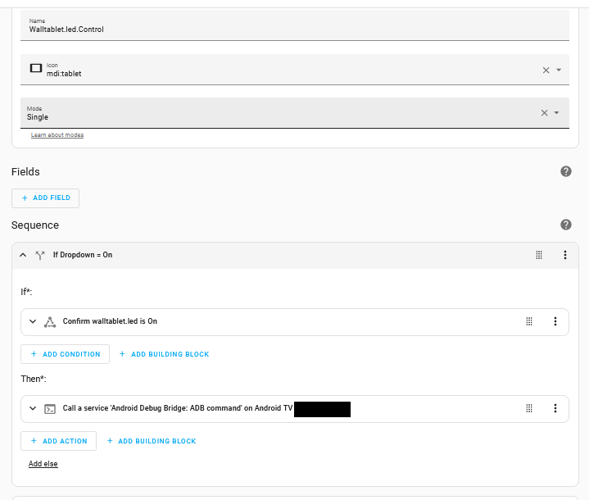

After you have your script setup to toggle lights to drop down selection, you will create one automation, to watch for state change of the helper, when the state changes run the script you just created to control the light ring.

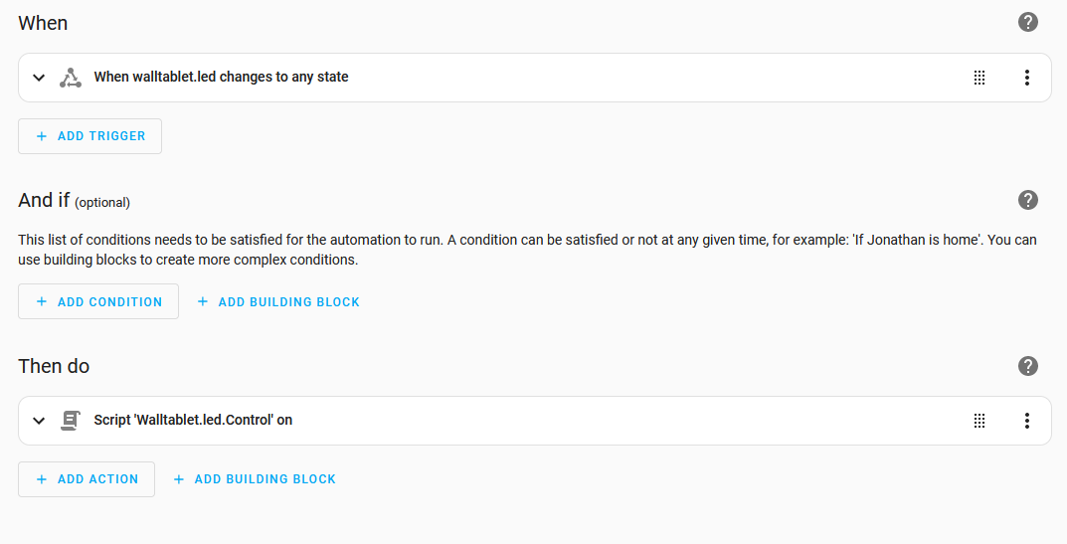
Here is an example of what mine looks like.

After this you have the ability to set the helper to the value you need, so in automation you can set helper to on, then chosen color, in automatons to control the led.

If anyone has any luck getting brightness modifications working or any more luck in controlling more features of this tablet series. Please let me know and we can get this document updated, please just link the document here on git hub while sharing.

Resources:
https://yixu-elec.com/call-led-indicators-meeting-roomdisplay/

Tablet Update (Shared) includes RKDevTools for windows.
Link Shared By Seller

Tablet SDKS (Shared)
Link Shared By Seller

